What is the relationship between SGML,HTML , XML and HTML?

SGML (Standard generalized markup language) is a standard which tells how to specify document markup. It’s only a Meta language which describes how a document markup should be. HTML is a markup language which is described using SGML.

So by SGML they created DTD which the HTML refers and needs to adhere to the same. So you will always find “DOCTYPE” attribute at the top of HTML page which defines which DTD is used for parsing purpose.

http://www.codeproject.com/images/minus.gif Collapse | [Copy Code](http://www.codeproject.com/Articles/702051/important-HTML-Interview-questions-with-answe)

<!DOCTYPE html PUBLIC "-//W3C//DTD HTML 4.01//EN" "http://www.w3.org/TR/html4/strict.dtd">

Now parsing SGML was a pain so they created XML to make things better. XML uses SGML. For example in SGML you have to start and end tags but in XML you can have closing tags which close automatically (“”).

XHTML was created from XML which was used in HTML 4.0. So for example in SGML derived HTML “  
” is not valid but in XHTML it’s valid. You can refer XML DTD as shown in the below code snippet.

http://www.codeproject.com/images/minus.gif Collapse | [Copy Code](http://www.codeproject.com/Articles/702051/important-HTML-Interview-questions-with-answe)

<!DOCTYPE html PUBLIC "-//W3C//DTD XHTML 1.0 Transitional//EN" "http://www.w3.org/TR/xhtml1/DTD/xhtml1-transitional.dtd">

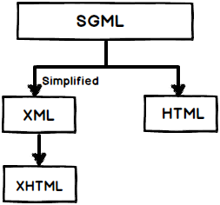

In short SGML is the parent of every one. Older HTML utilizes SGML and HTML 4.0 uses XHTML which derived from XML.

What is HTML 5?

HTML 5 is a new standard for HTML whose main target is to deliver everything without need to any additional plugins like flash, Silverlight etc. It has everything from animations, videos, rich GUI etc.  
HTML5 is cooperation output between World Wide Web Consortium (W3C) and the Web Hypertext Application Technology Working Group (WHATWG).

In HTML 5 we do not need DTD why?

HTML 5 does not use SGML or XHTML it’s completely a new thing so you do not need to refer DTD. For HTML 5 you just need to put the below doctype code which makes the browser identify that this is a HTML 5 document.

http://www.codeproject.com/images/minus.gif Collapse | [Copy Code](http://www.codeproject.com/Articles/702051/important-HTML-Interview-questions-with-answe)

<!DOCTYPE html>

If I do not put <! DOCTYPE html> will HTML 5 work?

No, browser will not be able to identify that it’s a HTML document and HTML 5 tags will not function properly.

Which browsers support HTML 5?

Almost all browsers i.e. Safari, Chrome, Firefox, Opera, Internet Explorer support HTML 5.

How is the page structure of HTML 5 different from HTML 4 or previous HTML?

A typical web page has headers, footers, navigation, central area and side bars. Now if we want to represent the same in HTML 4 with proper names to the HTML section we would probably use a DIV tag.  
But in HTML 5 they have made it more clear by creating element names for those sections which makes your HTML more readable.

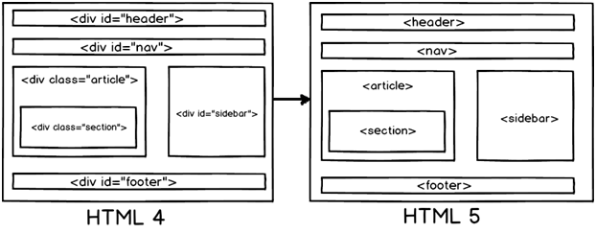

Below are more details of the HTML 5 elements which form the page structure.

* <header>: Represents header data of HTML.
* <footer>: Footer section of the page.
* <nav>: Navigation elements in the page.
* <article>: Self-contained content.
* <section>: Used inside article to define sections or group content in to sections.
* <aside>: Represent side bar contents of a page.

What is datalist in HTML 5?

Datalist element in HTML 5 helps to provide autocomplete feature in a textbox as shown below.

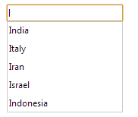

Below is the HTML code for DataList feature:-

http://www.codeproject.com/images/minus.gif Collapse | [Copy Code](http://www.codeproject.com/Articles/702051/important-HTML-Interview-questions-with-answe)

<input list="Country">

<datalist id="Country">

<option value="India">

<option value="Italy">

<option value="Iran">

<option value="Israel">

<option value="Indonesia">

</datalist>

What are the different new form element types in HTML 5?

There are 10 important new form elements introduced in HTML 5:-

1. Color.
2. Date
3. Datetime-local
4. Email
5. Time
6. Url
7. Range
8. Telephone
9. Number
10. Search

Let’s understand these elements step by step.

If you want to show color picker dialog box.

http://www.codeproject.com/images/minus.gif Collapse | [Copy Code](http://www.codeproject.com/Articles/702051/important-HTML-Interview-questions-with-answe)

<input type="color" name="favcolor">

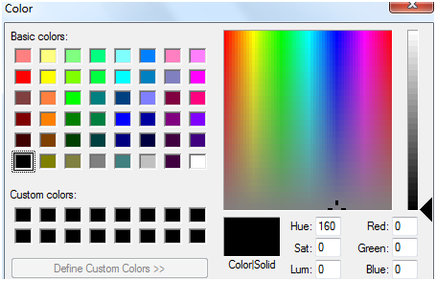

If you want to show calendar dialog box.

http://www.codeproject.com/images/minus.gif Collapse | [Copy Code](http://www.codeproject.com/Articles/702051/important-HTML-Interview-questions-with-answe)

<input type="date" name="bday">

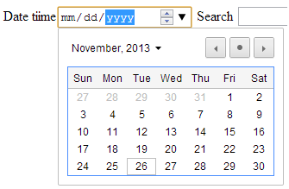

If you want to show calendar with local time.

http://www.codeproject.com/images/minus.gif Collapse | [Copy Code](http://www.codeproject.com/Articles/702051/important-HTML-Interview-questions-with-answe)

<input type="datetime-local" name="bdaytime">

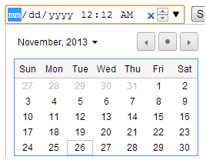

If you want to create a HTML text with email validation we can set the type as “email”.

http://www.codeproject.com/images/minus.gif Collapse | [Copy Code](http://www.codeproject.com/Articles/702051/important-HTML-Interview-questions-with-answe)

<input type="email" name="email">

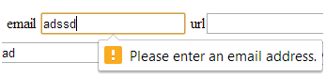

For URL validation set the type as “url” as shown in the below HTML code.

http://www.codeproject.com/images/minus.gif Collapse | [Copy Code](http://www.codeproject.com/Articles/702051/important-HTML-Interview-questions-with-answe)

<input type="url" name="sitename">

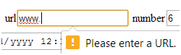

For URL validation set the type as “url” as shown in the below HTML code.

If you want to display textbox with number range you can set type to number.

http://www.codeproject.com/images/minus.gif Collapse | [Copy Code](http://www.codeproject.com/Articles/702051/important-HTML-Interview-questions-with-answe)

<input type="number" name="quantity" min="1" max="5">

http://www.codeproject.com/KB/aspnet/702051/image10.png

If you want to display a range control you can use type as range.

http://www.codeproject.com/images/minus.gif Collapse | [Copy Code](http://www.codeproject.com/Articles/702051/important-HTML-Interview-questions-with-answe)

<input type="range" min="0" max="10" step="2" value="6">

http://www.codeproject.com/KB/aspnet/702051/image11.png

Want to make text box as search engine box.

http://www.codeproject.com/images/minus.gif Collapse | [Copy Code](http://www.codeproject.com/Articles/702051/important-HTML-Interview-questions-with-answe)

<input type="search" name="googleengine">

What to only take time input.

http://www.codeproject.com/images/minus.gif Collapse | [Copy Code](http://www.codeproject.com/Articles/702051/important-HTML-Interview-questions-with-answe)

<input type="time" name="usr_time">

If you want to make text box to accept telephone numbers.

http://www.codeproject.com/images/minus.gif Collapse | [Copy Code](http://www.codeproject.com/Articles/702051/important-HTML-Interview-questions-with-answe)

<input type="tel" name="mytel">

What is output element in HTML 5?

Output element is needed when you need calculation from two inputs to be summarized in to a label. For instance you have two textboxes( see the below figure) and you want to add numbers from these textboxes and send them to a label.

http://www.codeproject.com/KB/aspnet/702051/image12.png

Below goes the code of how to use output element with HTML 5.

http://www.codeproject.com/images/minus.gif Collapse | [Copy Code](http://www.codeproject.com/Articles/702051/important-HTML-Interview-questions-with-answe)

<form onsubmit="return false" öninput="o.value = parseInt(a.value) + parseInt(b.value)">

<input name="a" type="number"> +

<input name="b" type="number"> =

<output name="o" />

</form>

You can also replace “parseInt” with “valueAsNumber” for simplicity. You can also use “for” in the output element for more readability.

http://www.codeproject.com/images/minus.gif Collapse | [Copy Code](http://www.codeproject.com/Articles/702051/important-HTML-Interview-questions-with-answe)

<output name="o" for="a b"></output>

What is SVG?

SVG stands for scalable vector graphics. It’s a text based graphic language which draws images using text, lines, dots etc. This makes it lightweight and renders faster.

Can we see a simple example of SVG using HTML 5?

Let’s say we want to display the below simple line using HTML 5 SVG.

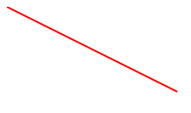

Below is how the code of HTML 5. You can see the SVG tag which encloses the polygon tag for displaying the star image.

http://www.codeproject.com/images/minus.gif Collapse | [Copy Code](http://www.codeproject.com/Articles/702051/important-HTML-Interview-questions-with-answe)

<svg id="svgelem" height="[object SVGAnimatedLength]" xmlns="http://www.w3.org/2000/svg">

<line style="stroke: rgb(255, 0, 0); stroke-width: 2px;" y2="[object SVGAnimatedLength]" x2="[object SVGAnimatedLength]" y1="[object SVGAnimatedLength]" x1="[object SVGAnimatedLength]">

</line>

What is canvas in HTML 5?

Canvas is an HTML area on which you can draw graphics.

So how can we draw a simple line on Canvas?

* Define the Canvas area.
* Get access to canvas context area.
* Draw the graphic.

**Define the canvas area**

So to define canvas area you need to use the below HTML code. This defines the area on which you can draw.

http://www.codeproject.com/images/minus.gif Collapse | [Copy Code](http://www.codeproject.com/Articles/702051/important-HTML-Interview-questions-with-answe)

<canvas id="mycanvas" width="600" height="500" style="border:1px solid #000000;"></canvas>

**Get access to canvas area**

To draw on the canvas area we need to first get reference of the context section. Below is the code for canvas section.

http://www.codeproject.com/images/minus.gif Collapse | [Copy Code](http://www.codeproject.com/Articles/702051/important-HTML-Interview-questions-with-answe)

var c=document.getElementById("mycanvas");

var ctx=c.getContext("2d");

**Draw the graphic**

Now once you have access to the context object we can start drawing on the context. So first call the “move” method and start from a point , use line method and draw the line and then apply stroke over it.

http://www.codeproject.com/images/minus.gif Collapse | [Copy Code](http://www.codeproject.com/Articles/702051/important-HTML-Interview-questions-with-answe)

ctx.moveTo(10,10);

ctx.lineTo(200,100);

ctx.stroke();

Below is the complete code.

http://www.codeproject.com/images/minus.gif Collapse | [Copy Code](http://www.codeproject.com/Articles/702051/important-HTML-Interview-questions-with-answe)

<body önload="DrawMe();">

<canvas id="mycanvas" width="600" height="500" style="border:1px solid #000000;"></canvas>

</body>

<script>

function DrawMe()

{

var c=document.getElementById("mycanvas");

var ctx=c.getContext("2d");

ctx.moveTo(10,10);

ctx.lineTo(200,100);

ctx.stroke();

}

You should get the below output.

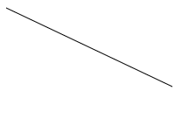

What is the difference between Canvas and SVG graphics?

***Note: -****If you see the previous two questions both canvas and SVG can draw graphics on the browser. So in this question interviewer wants to know when will you use what.*

|  |  |
| --- | --- |
| **SVG** | **Canvas** |
| Here’s it’s like draw and remember. In other words any shape drawn by using SVG can be remembered and manipulated and browser can render it again. | Canvas is like draw and forget. Once something is drawn you cannot access that pixel and manipulate it. |
| SVG is good for creating graphics like CAD software’s where once something is drawn the user wants to manipulate it. | Canvas is good for draw and forget scenarios like animation and games. |
| This is slow as it needs to remember the co-ordinates for later manipulations. | This is faster as there is no intention of remembering things later. |
| We can have event handler associated with the drawing object. | Here we cannot associate event handlers with drawing objects as we do not have reference of them. |
| Resolution independent. | Resolution dependent. |

How to draw rectangle using Canvas and SVG using HTML 5?

HTML 5 code Rectangle code using SVG.

http://www.codeproject.com/images/minus.gif Collapse | [Copy Code](http://www.codeproject.com/Articles/702051/important-HTML-Interview-questions-with-answe)

<svg xmlns="http://www.w3.org/2000/svg" version="1.1">

<rect style="fill: rgb(0, 0, 255); stroke-width: 1px; stroke: rgb(0, 0, 0);" height="[object SVGAnimatedLength]" width="[object SVGAnimatedLength]">

</rect>

HTML 5 Rectangle code using canvas.

http://www.codeproject.com/images/minus.gif Collapse | [Copy Code](http://www.codeproject.com/Articles/702051/important-HTML-Interview-questions-with-answe)

var c=document.getElementById("myCanvas");

var ctx=c.getContext("2d");

ctx.rect(20,20,150,100);

ctx.stroke();

<svg xmlns="http://www.w3.org/2000/svg" version="1.1">

<circle fill="red" stroke-width="2" stroke="black" r="[object SVGAnimatedLength]" cy="[object SVGAnimatedLength]" cx="[object SVGAnimatedLength]">

var canvas = document.getElementById('myCanvas');

var context = canvas.getContext('2d');

var centerX = canvas.width / 2;

var centerY = canvas.height / 2;

var radius = 70;

context.beginPath();

context.arc(centerX, centerY, radius, 0, 2 * Math.PI, false);

context.fillStyle = 'green';

context.fill();

context.lineWidth = 5;

context.strokeStyle = '#003300';

context.stroke();

<!DOCTYPE html>

<html>

<body önload="DrawMe();">

<svg height="[object SVGAnimatedLength]" width="[object SVGAnimatedLength]">

<circle id="circle1" cx="[object SVGAnimatedLength]" cy="[object SVGAnimatedLength]" r="[object SVGAnimatedLength]" style="stroke: none; fill: rgb(255, 0, 0);">

</body>

<script>

var timerFunction = setInterval(DrawMe, 20);

alert("ddd");

function DrawMe()

{

var circle = document.getElementById("circle1");

var x = circle.getAttribute("cx");

var newX = 2 + parseInt(x);

if(newX > 500)

{

newX = 20;

}

circle.setAttribute("cx", newX);

}

</script>

</html></circle>

What are selectors in CSS?

Selectors help to select an element to which you want to apply a style. For example below is a simple style called as ‘intro” which applies red color to background of a HTML element.

http://www.codeproject.com/images/minus.gif Collapse | [Copy Code](http://www.codeproject.com/Articles/702051/important-HTML-Interview-questions-with-answe)

<style>

.intro

{

background-color:red;

}

</style>

To apply the above “intro” style to div we can use the “class” selector as shown in the below figure.

http://www.codeproject.com/images/minus.gif Collapse | [Copy Code](http://www.codeproject.com/Articles/702051/important-HTML-Interview-questions-with-answe)

<div class="intro">

<p>My name is Shivprasad koirala.</p>

<p>I write interview questions.</p>

</div>

How can you apply CSS style using ID value?

So let’s say you have a HTML paragraph tag with id “mytext” as shown in the below snippet.

http://www.codeproject.com/images/minus.gif Collapse | [Copy Code](http://www.codeproject.com/Articles/702051/important-HTML-Interview-questions-with-answe)

<p id="mytext">This is HTML interview questions.</p>

You can create a style using “#” selector with the “id” name and apply the CSS value to the paragraph tag. So to apply style to “mytext” element we can use “#mytext” as shown in the below CSS code.

http://www.codeproject.com/images/minus.gif Collapse | [Copy Code](http://www.codeproject.com/Articles/702051/important-HTML-Interview-questions-with-answe)

<style>

#mytext

{

background-color:yellow;

}

</style>

**Quick revision of some important selectors.**

Set all paragraph tags back ground color to yellow.

http://www.codeproject.com/images/minus.gif Collapse | [Copy Code](http://www.codeproject.com/Articles/702051/important-HTML-Interview-questions-with-answe)

P,h1

{

background-color:yellow;

}

Sets all paragraph tags inside div tag to yellow background.

http://www.codeproject.com/images/minus.gif Collapse | [Copy Code](http://www.codeproject.com/Articles/702051/important-HTML-Interview-questions-with-answe)

div p

{

background-color:yellow;

}

Sets all paragraph tags following div tags to yellow background.

http://www.codeproject.com/images/minus.gif Collapse | [Copy Code](http://www.codeproject.com/Articles/702051/important-HTML-Interview-questions-with-answe)

div+p

{

background-color:yellow;

}

Sets all attribute with “target” to yellow background.

http://www.codeproject.com/images/minus.gif Collapse | [Copy Code](http://www.codeproject.com/Articles/702051/important-HTML-Interview-questions-with-answe)

a[target]

{

background-color:yellow;

}

<a href="http://www.questpond.com">ASP.NET interview questions</a>

<a href="http://www.questpond.com" target="_blank">c# interview questions</a>

<a href="http://www.questpond.org" target="_top">.NET interview questions with answers</a>

Set all elements to yellow background when control gets focus.

http://www.codeproject.com/images/minus.gif Collapse | [Copy Code](http://www.codeproject.com/Articles/702051/important-HTML-Interview-questions-with-answe)

input:focus

{

background-color:yellow;

}

Set hyperlinks according to action on links.

http://www.codeproject.com/images/minus.gif Collapse | [Copy Code](http://www.codeproject.com/Articles/702051/important-HTML-Interview-questions-with-answe)

a:link {color:green;}

a:visited {color:green;}

a:hover {color:red;}

a:active {color:yellow;}

What is the use of column layout in CSS?

CSS column layout helps you to divide your text in to columns. For example consider the below magazine news which is one big text but we need to divide the same in to 3 columns with a border in between. That’s where HTML 5 column layout comes to help.

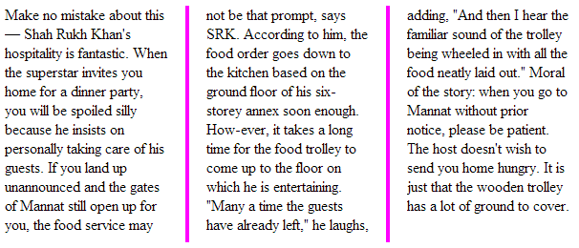

To implement column layout we need to specify the following:-

* How many columns we want to divide the text in to ?

To specify number of columns we need to us column-count. “webkit” and “moz-column” are needed for chrome and firefox respectively.

http://www.codeproject.com/images/minus.gif Collapse | [Copy Code](http://www.codeproject.com/Articles/702051/important-HTML-Interview-questions-with-answe)

-moz-column-count:3; */* Firefox */*

-webkit-column-count:3; */* Safari and Chrome */*

column-count:3;

* How much gap we want to give between those columns ?

http://www.codeproject.com/images/minus.gif Collapse | [Copy Code](http://www.codeproject.com/Articles/702051/important-HTML-Interview-questions-with-answe)

-moz-column-gap:40px; */* Firefox */*

-webkit-column-gap:40px; */* Safari and Chrome */*

column-gap:20px;

* Do you want to draw a line between those columns , if yes how much thick ?

http://www.codeproject.com/images/minus.gif Collapse | [Copy Code](http://www.codeproject.com/Articles/702051/important-HTML-Interview-questions-with-answe)

-moz-column-rule:4px outset #ff00ff; */* Firefox */*

-webkit-column-rule:4px outset #ff00ff; */* Safari and Chrome */*

column-rule:6px outset #ff00ff;

Below is the complete code for the same.

http://www.codeproject.com/images/minus.gif Collapse | [Copy Code](http://www.codeproject.com/Articles/702051/important-HTML-Interview-questions-with-answe)

<style>

.magazine

{

-moz-column-count:3; /* Firefox */

-webkit-column-count:3; /* Safari and Chrome */

column-count:3;

-moz-column-gap:40px; /* Firefox */

-webkit-column-gap:40px; /* Safari and Chrome */

column-gap:20px;

-moz-column-rule:4px outset #ff00ff; /* Firefox */

-webkit-column-rule:4px outset #ff00ff; /* Safari and Chrome */

column-rule:6px outset #ff00ff;

}

</style>

You can then apply the style to the text by using the class attribute.

http://www.codeproject.com/images/minus.gif Collapse | [Copy Code](http://www.codeproject.com/Articles/702051/important-HTML-Interview-questions-with-answe)

<div class="magazine">

Your text goes here which you want to divide in to 3 columns.

</div>

Can you explain CSS box model?

CSS box model is a rectangular space around a HTML element which defines border, padding and margin.

Border: - This defines the maximum area in which the element will be contained. We can make the border visible, invisible, define height and width etc.

Padding: - This defines the spacing between border and element.

Margin: - This defines the spacing between border and any neighboring elements.

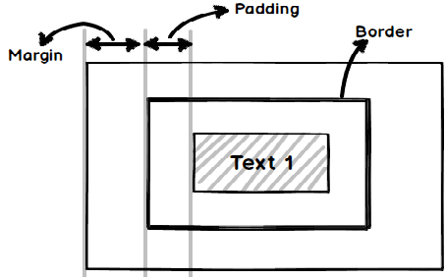

For instance below is a simple CSS code which defines a box with border , padding and margin values.

http://www.codeproject.com/images/minus.gif Collapse | [Copy Code](http://www.codeproject.com/Articles/702051/important-HTML-Interview-questions-with-answe)

.box {

width: 200px;

border: 10px solid #99c;

padding: 20px;

margin: 50px;

}

Now if we apply the above CSS to a DIV tag as shown in the below code , your output would be as shown in the figure below. I have created two test “Some text” and “Some other text” so that we can see how margin property functions.

http://www.codeproject.com/images/minus.gif Collapse | [Copy Code](http://www.codeproject.com/Articles/702051/important-HTML-Interview-questions-with-answe)

<div align="middle" class="box">

Some text

</div>

Some other text

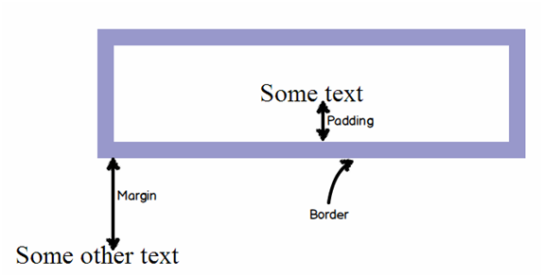

Can you explain some text effects in CSS 3?

Here the interviewer is expecting you to answer one of two text effects by CSS.Below are two effects which are worth noting.

Shadow text effect

http://www.codeproject.com/images/minus.gif Collapse | [Copy Code](http://www.codeproject.com/Articles/702051/important-HTML-Interview-questions-with-answe)

.specialtext

{

text-shadow: 5px 5px 5px #FF0000;

}

http://www.codeproject.com/KB/aspnet/702051/image18.png

Word wrap effect

http://www.codeproject.com/images/minus.gif Collapse | [Copy Code](http://www.codeproject.com/Articles/702051/important-HTML-Interview-questions-with-answe)

<style>

.breakword

{word-wrap:break-word;}

</style>

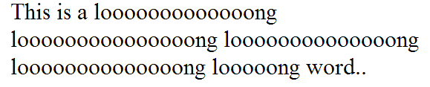

What are web workers and why do we need them ?

Consider the below heavy for loop code which runs above million times.

http://www.codeproject.com/images/minus.gif Collapse | [Copy Code](http://www.codeproject.com/Articles/702051/important-HTML-Interview-questions-with-answe)

function SomeHeavyFunction()

{

for (i = 0; i < 10000000000000; i++)

{

x = i + x;

}

}

Let’s say the above for loop code is executed on a HTML button click. Now this method execution is synchronous. In other words the complete browser will wait until the for loop completes.

http://www.codeproject.com/images/minus.gif Collapse | [Copy Code](http://www.codeproject.com/Articles/702051/important-HTML-Interview-questions-with-answe)

<input type="button" onclick="SomeHeavyFunction();" />

This can further lead to browser getting freezed and unresponsive with an error message as shown in the screen below.

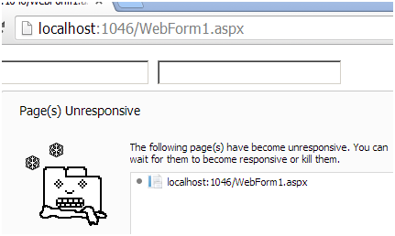

So if we can move this heavy for loop in a JavaScript file and run it asynchronously that means the browser does need to wait for the loop then we can have a more responsive browser. That’s what web worker are for.

Web worker helps to execute JavaScript file asynchronously.

What are the restrictions of Web Worker thread?

Web worker threads cannot modify HTML elements, global variables and some window properties like Window.Location. You are free to use javascript data types, XMLHttpRequest calls etc.

So how do we create a worker thread in JavaScript?

To create a worker thread we need to pass the JavaScript file name and create the worker object.

http://www.codeproject.com/images/minus.gif Collapse | [Copy Code](http://www.codeproject.com/Articles/702051/important-HTML-Interview-questions-with-answe)

var worker = new Worker("MyHeavyProcess.js");

To send message to the worker object we need to use “PostMessage” , below is the code for the same.

http://www.codeproject.com/images/minus.gif Collapse | [Copy Code](http://www.codeproject.com/Articles/702051/important-HTML-Interview-questions-with-answe)

worker.postMessage();

When the worker thread sends data we get it in the “OnMessage” event on the callers end.

http://www.codeproject.com/images/minus.gif Collapse | [Copy Code](http://www.codeproject.com/Articles/702051/important-HTML-Interview-questions-with-answe)

worker.onmessage = function (e)

{

document.getElementById("txt1").value = e.data;

};

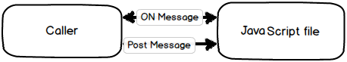

The heavy loop is in the “MyHeavyProcess.js” javascriptfile , below is the code for the same. When the JavaScript file wants to send message he uses “postmessage” and any message sent from the caller is received in the “onmessage” event.

http://www.codeproject.com/images/minus.gif Collapse | [Copy Code](http://www.codeproject.com/Articles/702051/important-HTML-Interview-questions-with-answe)

var x =0

self.onmessage = function (e) {

for (i = 0; i < 1000000000; i++)

{

x = i + x;

}

self.postMessage(x);

};

How to terminate a web worker?

http://www.codeproject.com/images/minus.gif Collapse | [Copy Code](http://www.codeproject.com/Articles/702051/important-HTML-Interview-questions-with-answe)

w.terminate();

Why do we need HTML 5 server-sent events?

One of the common requirements in web world is getting updates from the server. Take example of a stock ticker application where the browser has to take regular updates from the server for the recent stock value.

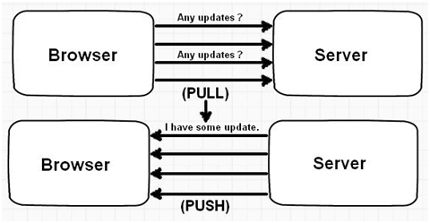

Now to implement this kind of requirement developers normally write some kind of PULL code which goes to the server and fetches data in certain interval. Now PULL solution is good but it makes the network chatty with lot of calls and also it adds load on the server.

So rather than PULL it would be great if we can have some kind of PUSH solution. In simple words when the server has updates it will send updates to the browser client. That can be achieved by using “SERVER SENT EVENTS”.

So the first thing the browser needs to do is connect to the server source which will send updates. Let’s say we have page “stock.aspx” which sends stock updates. So to connect to the page we need to use attach to the event source object as shown in the below code.

http://www.codeproject.com/images/minus.gif Collapse | [Copy Code](http://www.codeproject.com/Articles/702051/important-HTML-Interview-questions-with-answe)

var source = new EventSource("stock.aspx");

We also need to attach the function where we will receive messages when server sends update. For than we need to attach function to the “onmessage” event as shown in the below code.

http://www.codeproject.com/images/minus.gif Collapse | [Copy Code](http://www.codeproject.com/Articles/702051/important-HTML-Interview-questions-with-answe)

source.onmessage = function (event) {

document.getElementById("result").innerHTML += event.data + "<br>";

};

Now from the server side we need to send events. Below are some lists of important events with command that needs to be sent from the server side.

|  |  |
| --- | --- |
| **Event** | **Command** |
| Send data to the client. | data : hello |
| Tell client to retry in 10 seconds | retry : 10000 |
| Raise a specific event with data | event : successdata : You are logged in. |

So for example if we want to send data below is the ASP.NET code for the same. Please note the content type is set to text/event.

http://www.codeproject.com/images/minus.gif Collapse | [Copy Code](http://www.codeproject.com/Articles/702051/important-HTML-Interview-questions-with-answe)

Response.ContentType="text/event-stream";

Response.Expires=-1;

Response.Write("data: " + DateTime.Now.ToString());

Response.Flush();

To retry after 10 second below is the command.

http://www.codeproject.com/images/minus.gif Collapse | [Copy Code](http://www.codeproject.com/Articles/702051/important-HTML-Interview-questions-with-answe)

Response.Write("retry: 10000");

If you want to attach an event we need to use the “addEventListener” event as shown in the below code.

http://www.codeproject.com/images/minus.gif Collapse | [Copy Code](http://www.codeproject.com/Articles/702051/important-HTML-Interview-questions-with-answe)

source.addEventListener('message', function(e) {

console.log(e.data);

}, false);

From the server side the below message will trigger the “message” function of javascript.

http://www.codeproject.com/images/minus.gif Collapse | [Copy Code](http://www.codeproject.com/Articles/702051/important-HTML-Interview-questions-with-answe)

event: message

data : hello

What is local storage concept in HTML 5?

Many times we would like to store information about the user locally in the computer. For example let’s say user has half-filled a long form and suddenly the internet connection breaks off. So the user would like you to store this information locally and when the internet comes back.He would like to get that information and send it to the server for storage.

Modern browsers have storage called as “Local storage” in which you can store this information.

How can we add and remove data from local storage?

Data is added to local storage using “key” and “value”. Below sample code shows country data “India” added with key value “Key001”.

http://www.codeproject.com/images/minus.gif Collapse | [Copy Code](http://www.codeproject.com/Articles/702051/important-HTML-Interview-questions-with-answe)

localStorage.setItem(“Key001”,”India”);

To retrieve data from local storage we need to use “getItem” providing the key name.

http://www.codeproject.com/images/minus.gif Collapse | [Copy Code](http://www.codeproject.com/Articles/702051/important-HTML-Interview-questions-with-answe)

var country = localStorage.getItem(“Key001”);

You can also store JavaScript object’s in the local storage using the below code.

http://www.codeproject.com/images/minus.gif Collapse | [Copy Code](http://www.codeproject.com/Articles/702051/important-HTML-Interview-questions-with-answe)

var country = {};

country.name = “India”;

country.code = “I001”;

localStorage.setItem(“I001”, country);

var country1 = localStorage.getItem(“I001”);

If you want to store in JSON format you can use “JSON.stringify” function as shown in the below code.

http://www.codeproject.com/images/minus.gif Collapse | [Copy Code](http://www.codeproject.com/Articles/702051/important-HTML-Interview-questions-with-answe)

localStorage.setItem(“I001”,JSON.stringify(country));

What is the lifetime of local storage?

Local storage does not have a life time it will stay until either the user clear it from the browser or you remove it using JavaScript code.

What is the difference between local storage and cookies?

|  |  |  |
| --- | --- | --- |
|  | **Cookies** | **Local storage** |
| **Client side / Server side.** | Data accessible both at client side and server side. Cookie data is sent to the server side with every request. | Data is accessible only at the local browser side. Server cannot access local storage until deliberately sent to the server via POST or GET. |
| **Size** | 4095 bytes per cookie. | 5 MB per domain. |
| **Expiration** | Cookies have expiration attached to it. So after that expiration the cookie and the cookie data get’s deleted. | There is no expiration data. Either the end user needs to delete it from the browser or programmatically using JavaScript we need to remove the same. |

What is session storage and how can you create one?

Session storage is same like local storage but the data is valid for a session. In simple words the data is deleted as soon as you close the browser.

To create a session storage you need to use “sessionStorage.variablename” . In the below code we have a created a variable called as “clickcount”.

If you refresh the browser the count increases. But if you close the browser and start again the “clickcount” variable starts from zero.

http://www.codeproject.com/images/minus.gif Collapse | [Copy Code](http://www.codeproject.com/Articles/702051/important-HTML-Interview-questions-with-answe)

if(sessionStorage.clickcount)

{

sessionStorage.clickcount=Number(sessionStorage.clickcount)+1;

}

else

{

sessionStorage.clickcount = 0;

}

What is difference between session storage and local storage?

Local storage data persists forever but session storage is valid until the browser is open, as soon as the browser closes the session variable resets.

What is WebSQL?

WebSQL is a structured relational database at the client browser side. It’s a local RDBMS inside the browser on which you can fire SQL queries.

Is WebSQL a part of HTML 5 specification?

No, many people label it as HTML 5 but it’s not part of HTML 5 specification. The specification is based around SQLite.

So how can we use WebSQL?

The first step we need to do is open the database by using “OpenDatabase” function as shown below. The first argument is the name of the database, the next is the version, then a simple textual title and finally the size of the database.

http://www.codeproject.com/images/minus.gif Collapse | [Copy Code](http://www.codeproject.com/Articles/702051/important-HTML-Interview-questions-with-answe)

var db=openDatabase('dbCustomer','1.0','Customer app’, 2 * 1024 * 1024);

To execute SQL we then need to use “transaction” function and call “executeSql” function to fire SQL.

http://www.codeproject.com/images/minus.gif Collapse | [Copy Code](http://www.codeproject.com/Articles/702051/important-HTML-Interview-questions-with-answe)

db.transaction(function (tx)

{

tx.executeSql('CREATE TABLE IF NOT EXISTS tblCust(id unique, customername)');

tx.executeSql('INSERT INTO tblcust (id, customername) VALUES(1, "shiv")');

tx.executeSql('INSERT INTO tblcust (id, customername) VALUES (2, "raju")');

}

In case you are firing “select” query you will get data is “results” collection which we can loop and display in the HTML UI.

http://www.codeproject.com/images/minus.gif Collapse | [Copy Code](http://www.codeproject.com/Articles/702051/important-HTML-Interview-questions-with-answe)

db.transaction(function (tx)

{

tx.executeSql('SELECT * FROM tblcust', [], function (tx, results) {

for (i = 0; i < len; i++)

{

msg = "<p><b>" + results.rows.item(i).log + "</b></p>";

document.querySelector('#customer).innerHTML += msg;

}

}, null);

});

What is application cache in HTML5?

One of the most demanded things by end user is offline browsing. In other words if internet connection is not available page should come from browser cache i.e. offline and application cache helps you to achieve the same.

Application cache helps you to specify which files should be cached and not cached.

So how do we implement application cache in HTML 5?

The first thing in we need to specify is the “manifest” file. “manifest” file helps you to define how your caching should work. Below is the structure of the manifest file :-

http://www.codeproject.com/images/minus.gif Collapse | [Copy Code](http://www.codeproject.com/Articles/702051/important-HTML-Interview-questions-with-answe)

CACHE MANIFEST

# version 1.0

CACHE :

Login.aspx

* All manifest file starts with CACHE MANIFEST statement.
* #( hash tag) helps to provide the version of the cache file.
* CACHE command specifies which files needs to be cached.
* The content type of the manifest file should be “text/cache-manifest”.

Below is how cache manifest has been provided using ASP.NET C#.

http://www.codeproject.com/images/minus.gif Collapse | [Copy Code](http://www.codeproject.com/Articles/702051/important-HTML-Interview-questions-with-answe)

Response.ContentType = "text/cache-manifest";

Response.Write("CACHE MANIFEST \n");

Response.Write("# 2012-02-21 v1.0.0 \n");

Response.Write("CACHE : \n");

Response.Write("Login.aspx \n");

Response.Flush();

Response.End();

One the cache manifest file is created the next thing is to provide the link of the manifest file in the HTML page as shown below.

http://www.codeproject.com/images/minus.gif Collapse | [Copy Code](http://www.codeproject.com/Articles/702051/important-HTML-Interview-questions-with-answe)

<html manifest="cache.aspx">

When the above file runs first time it gets added in the browser application cache and in case server goes down the page is served from the application cache.

So how do we refresh the application cache of the browser?

Application cache is removed by changing version number to a new version number as specified in the “#” tag in the below code.

http://www.codeproject.com/images/minus.gif Collapse | [Copy Code](http://www.codeproject.com/Articles/702051/important-HTML-Interview-questions-with-answe)

CACHE MANIFEST

# version 2.0(new)

CACHE :

Login.aspx

Aboutus.aspx

NETWORK :

Pages.aspx

What is fallback in Application cache?

Fallback in application cache helps you to specify the file which will displayed if the server is not reachable. For instance in the below manifest file we are saying if someone hits “/home” and if the server is not reachable then “homeoffline.html” file should be served.

http://www.codeproject.com/images/minus.gif Collapse | [Copy Code](http://www.codeproject.com/Articles/702051/important-HTML-Interview-questions-with-answe)

FALLBACK:

/home/ /homeoffline.html

What is network in application cache?

Network command says files which should not be cached. For example in the below code we are saying that “home.aspx” should never be cached and or available offline.